Secrets Management with Amazon Key Management Service.
Why secrets management is important?
While we work on different services such RDS S3 buckets etc we can use service such as Amazon Key Management Service (KMS) to store passwords.
AWS KMS helps encrypt:
S3 buckets
EBS volumes
RDS databases
Lambda environment variables
Secrets
Files
Application data

Let’s do a Hands-On Demo
First let us create a S3 bucket
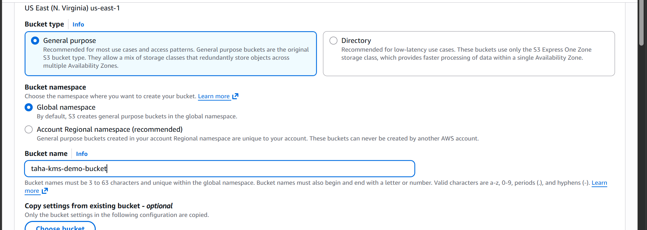
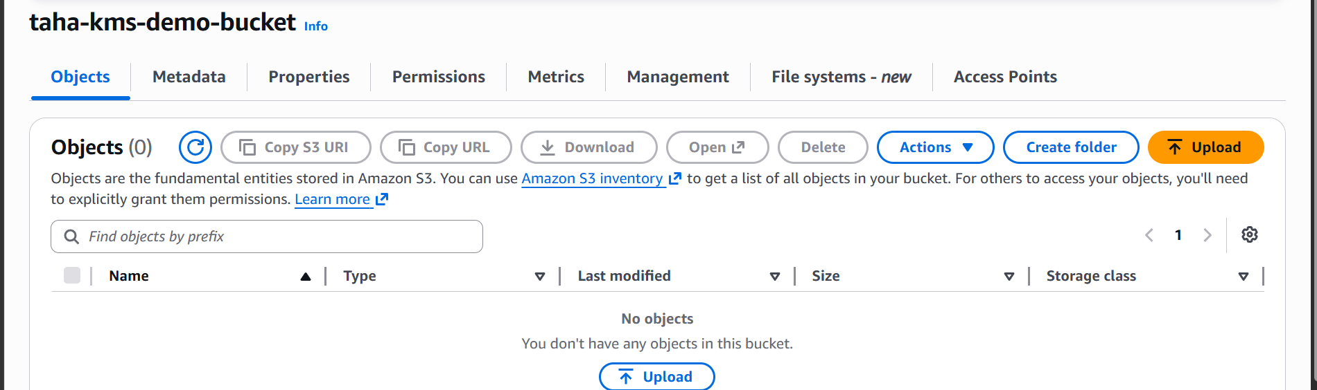

Now create a KMS key
Search for KMS
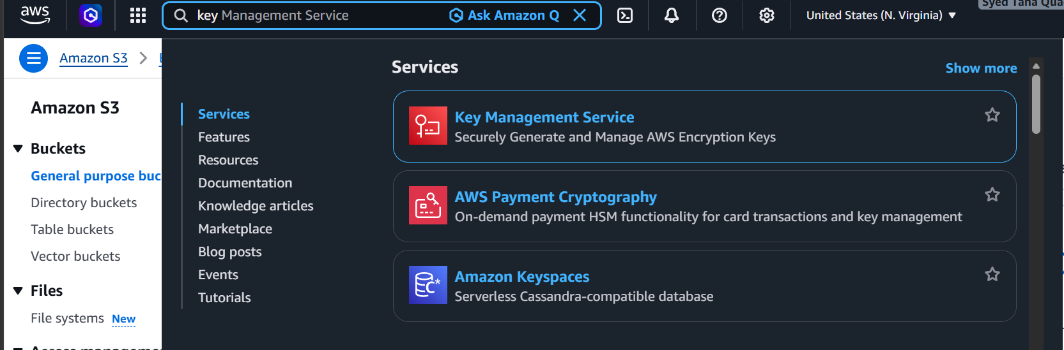

Select KMS
Click on customer managed keys
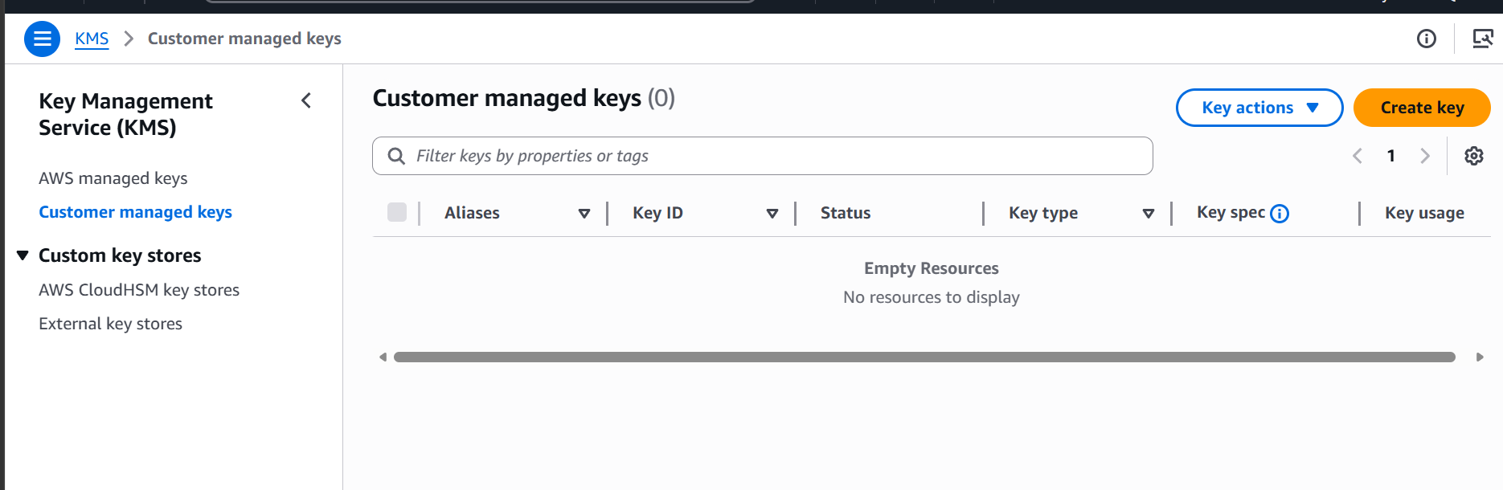
Click on create key
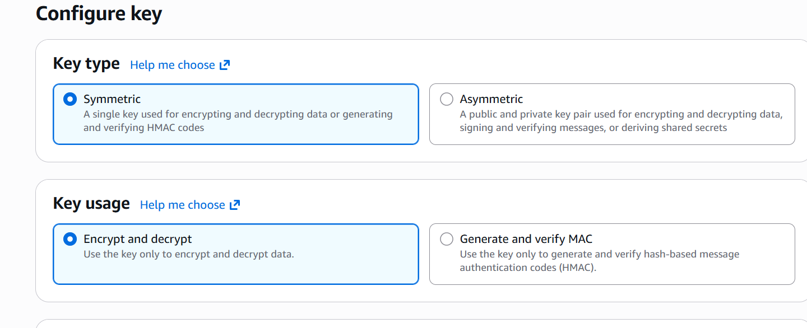

Select type and usage
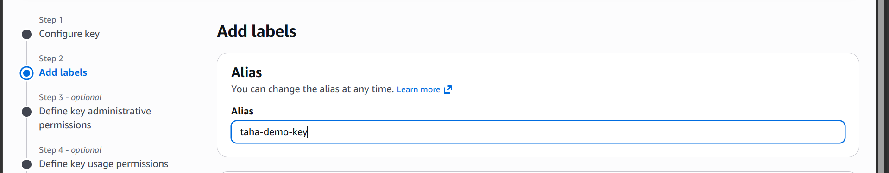

Add alias
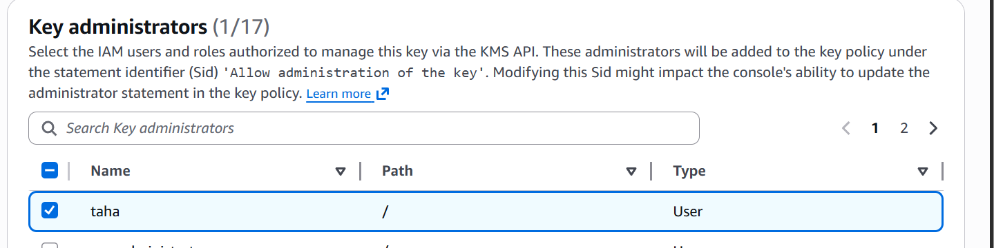

Select users
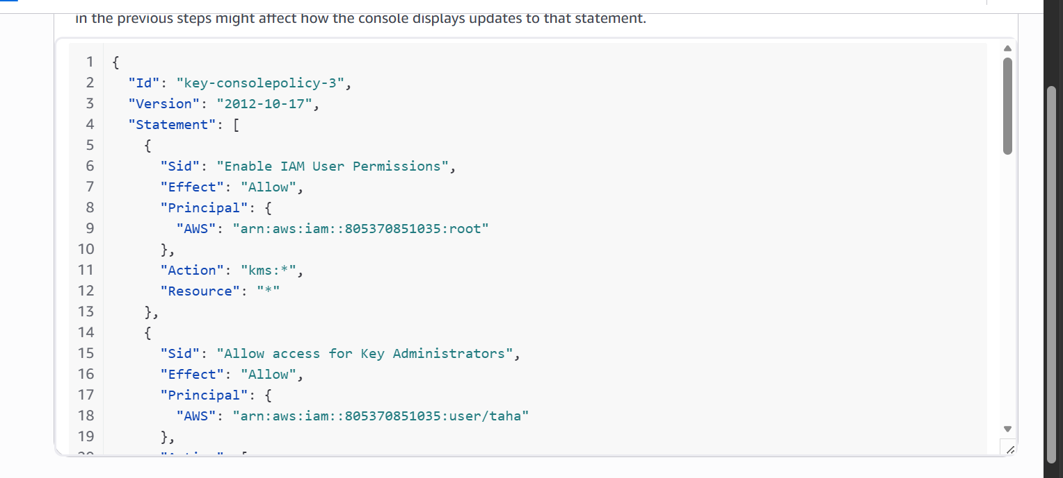
These users can:
manage key
enable/disable
rotate/delete

the key is now created
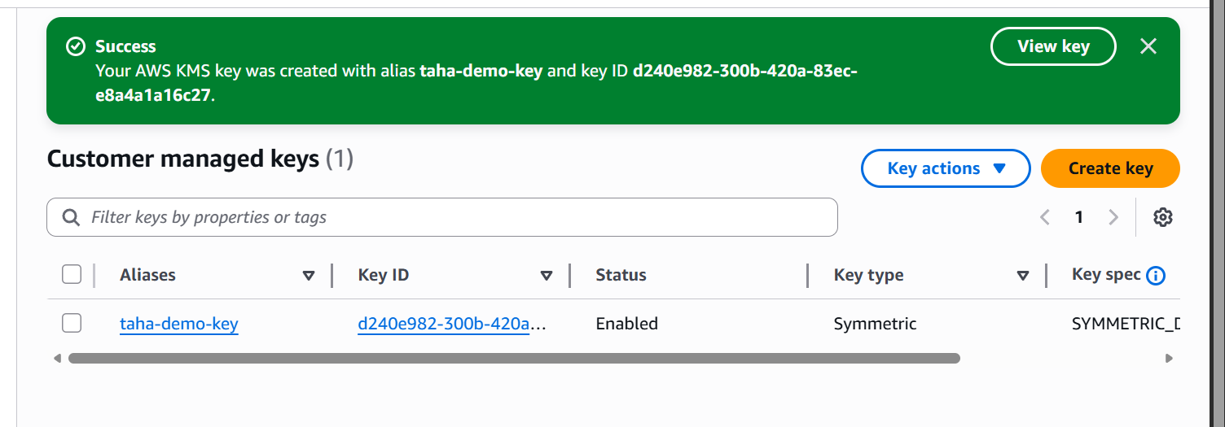

Now let us go to the s3 bucket and enable bucket encryption
Go to properties
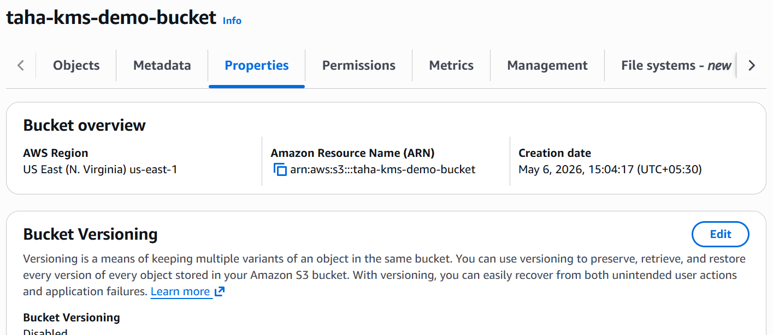
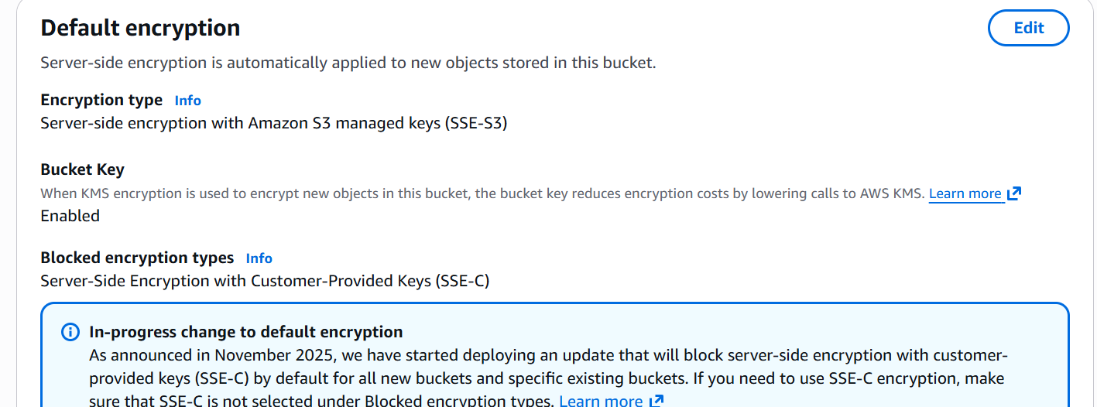

Click on edit
Select Server-side encryption with AWS Key Management Service keys (SSE-KMS) and select your key.
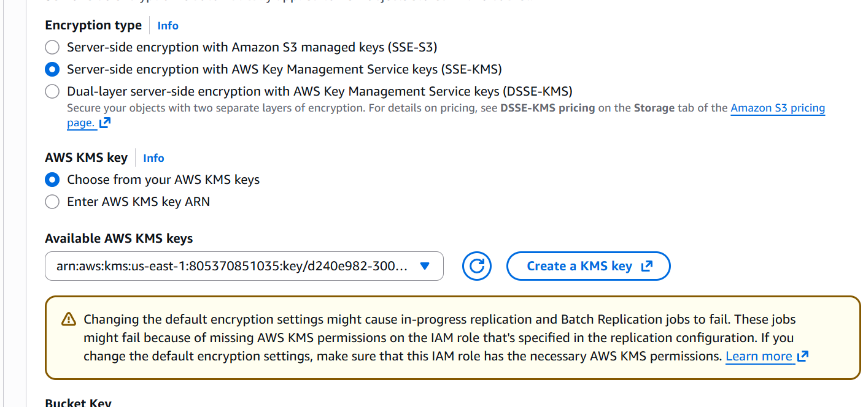

Now every file uploaded to this bucket will automatically be:
Encrypted using KMS
Let us now upload an object in our s3 bucket
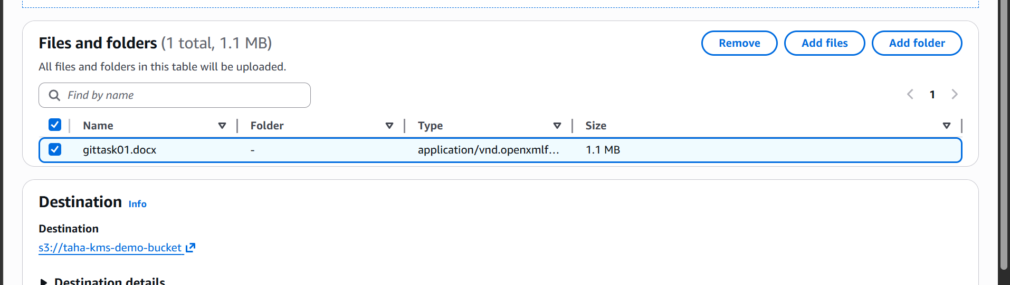

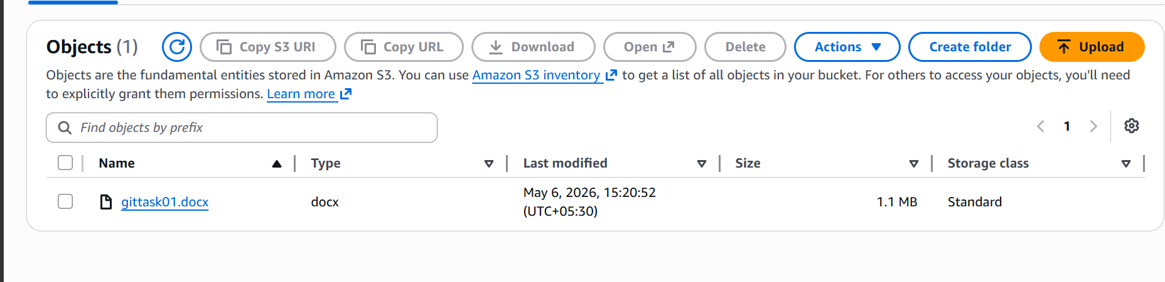

The object is now uploaded
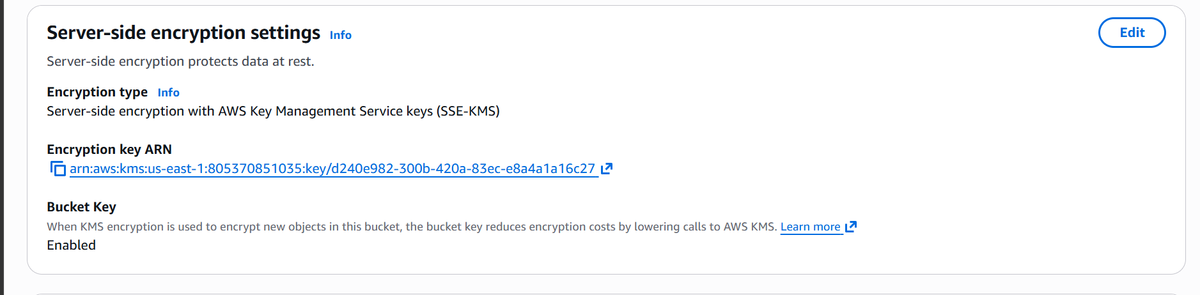
we can see that our object is encrypted with the key.
Let us remove the permissions from our created user and verify the encryption
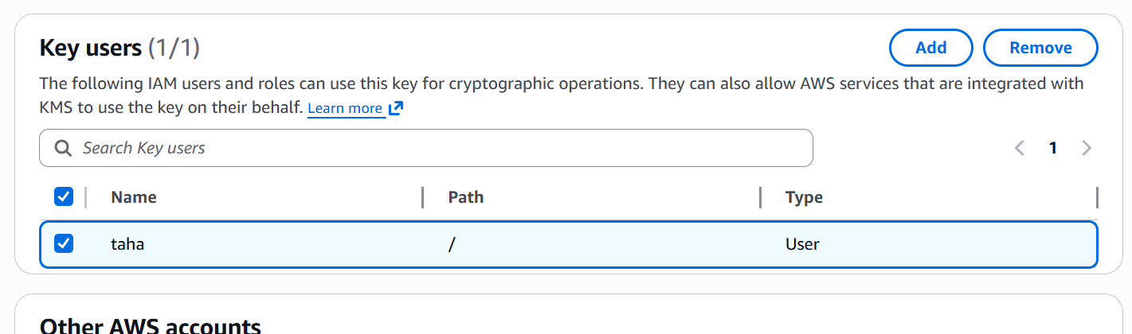

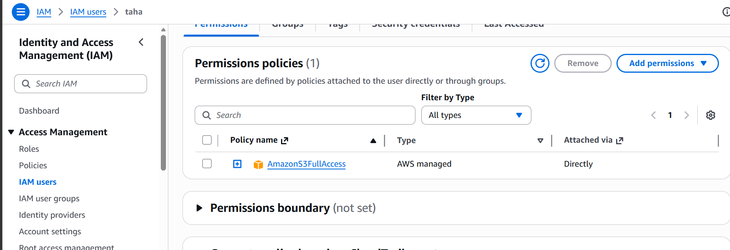
Just to confirm that our user has full S3 access

Let us switch to taha user
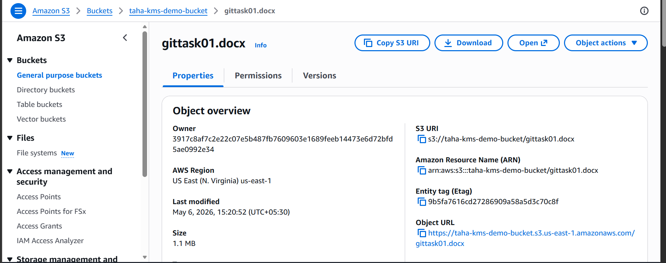

Let us now try to download the object
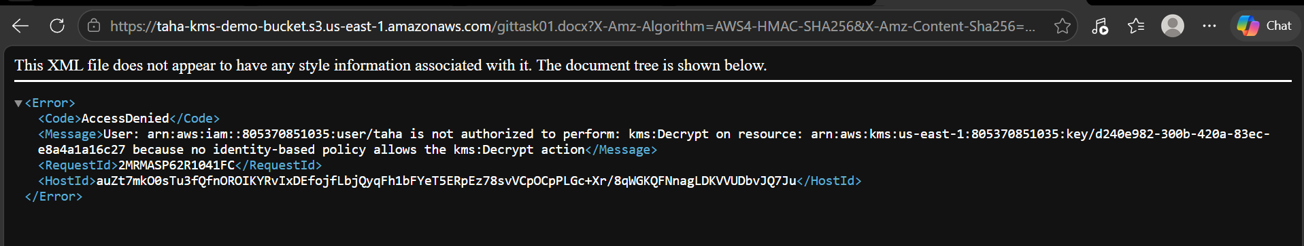

We can see that user taha is unable to download the object though he has the full access to S3.

